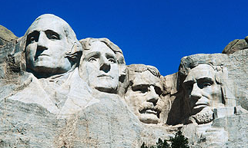

7:00 Open

Historical Commission – Sergeant Stetson House

Call to Order/Pledge of Allegiance

7:30 Citizen Comments

Approval of Minutes

Appointments

7:35 Energy Committee Update

7:45 Technology Committee Update

8:00 PBMC Committee Update

Old Business
- Goals & Policies

- Selectmen Articles

New Business

Close the Warrant for Special and Annual Town Meeting

- One Day Liquor License Request, James Library, 3/15/13

- Amend Date of James Library One Day Liquor License to 2/15/13

Upcoming Meetings

Announcements

Adjournment

Executive Session

